**Data Ingestion End-to-End Pipeline**

Course-end Project 1

1. Create a landing storage account in Azure (go to storage Account)

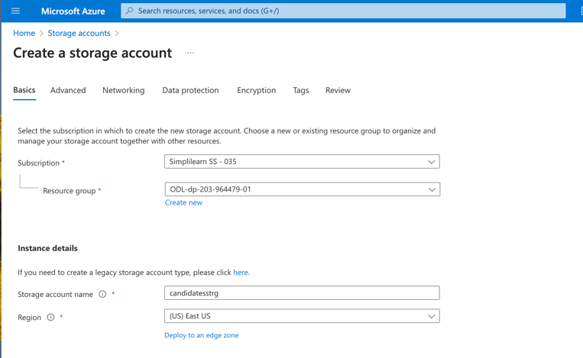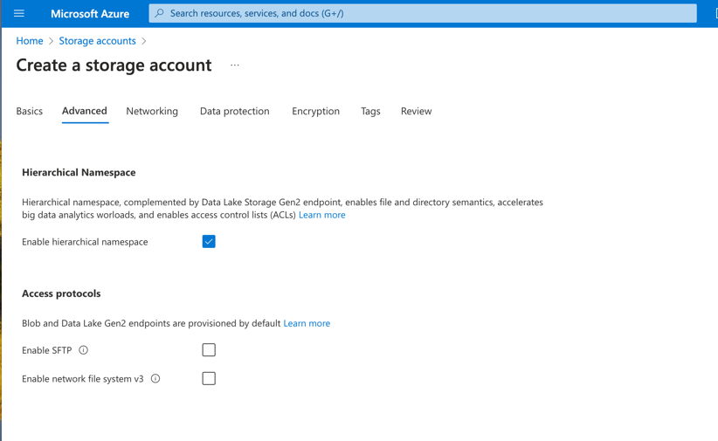



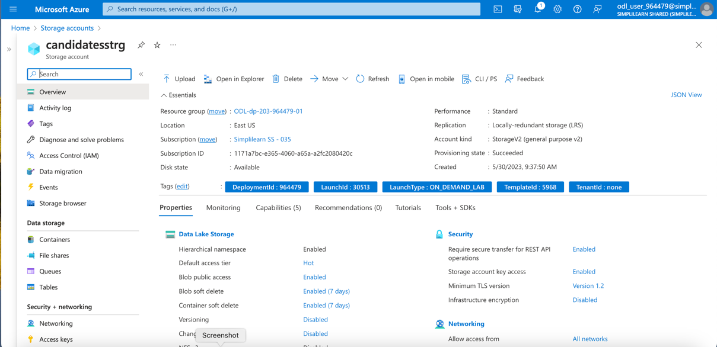

* Creating containers for the staging and landing files
  + Raw and candidates-parquet

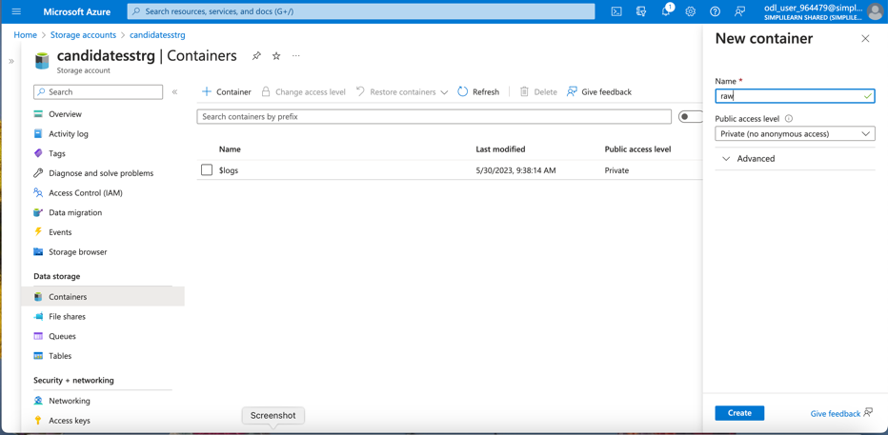



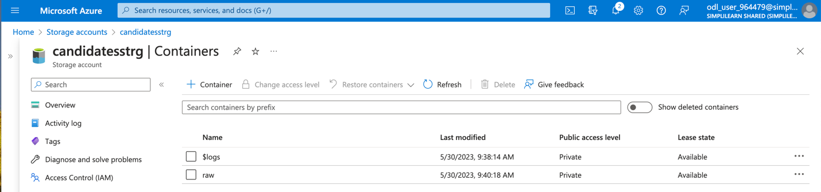

2- Store the CSV files in the storage account

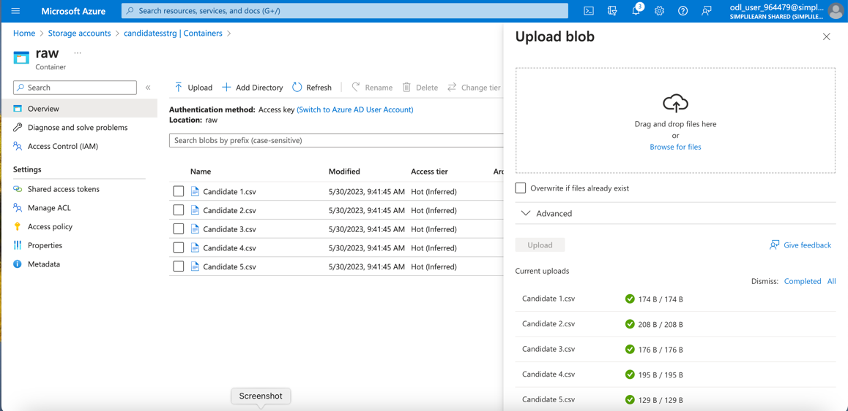

1. Create a staging storage account in Azure
   * Another folder created for Parquet file

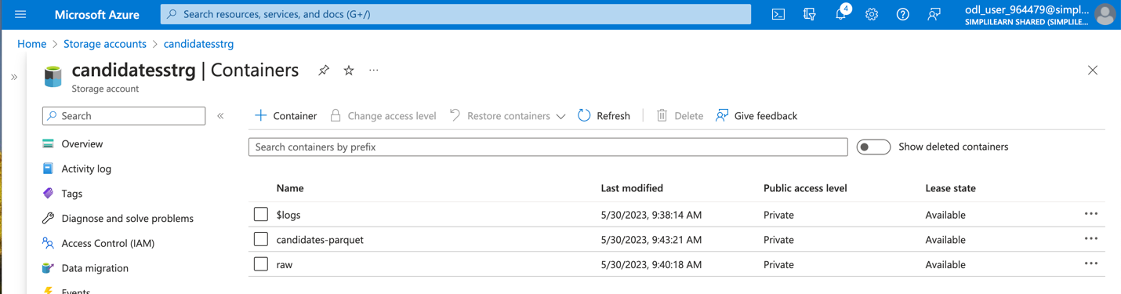



1. Create an Azure Data Factory resource and Azure Data Factory pipeline

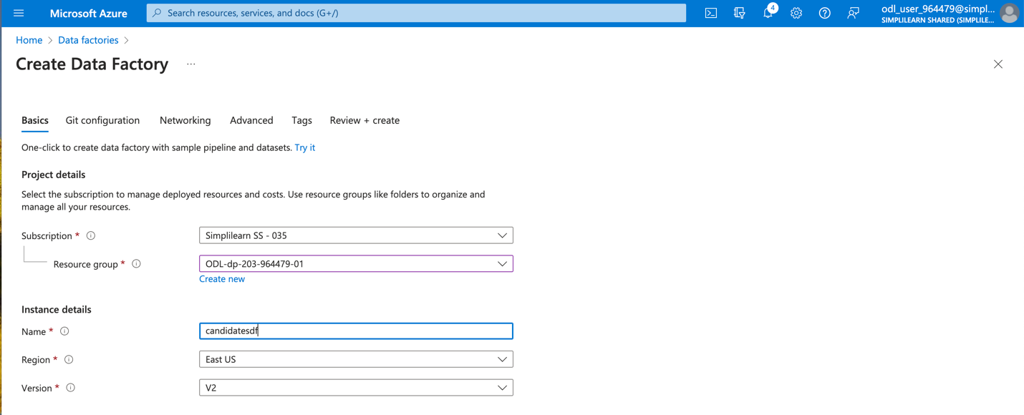



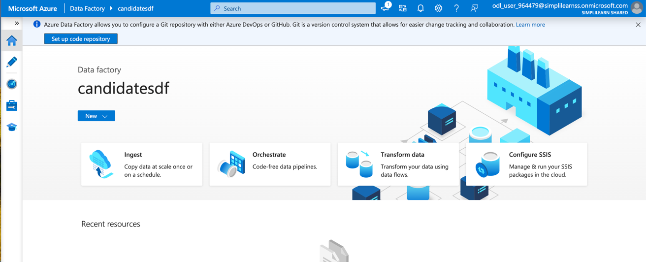

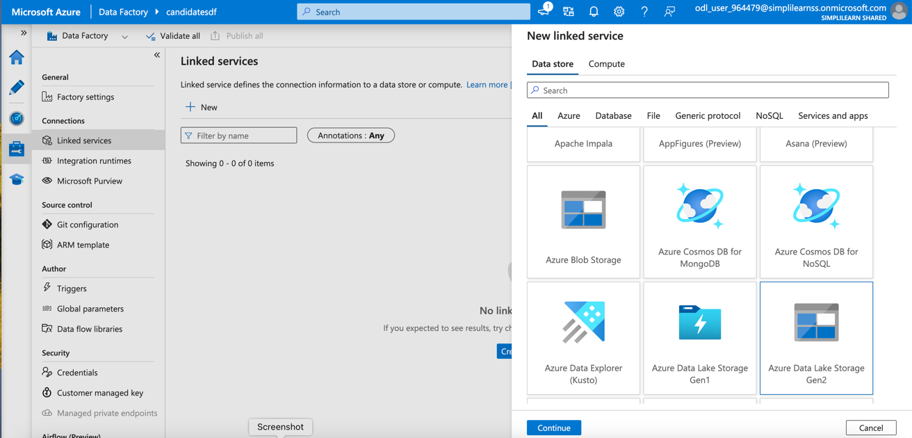



1. Create linked services for the storage accounts

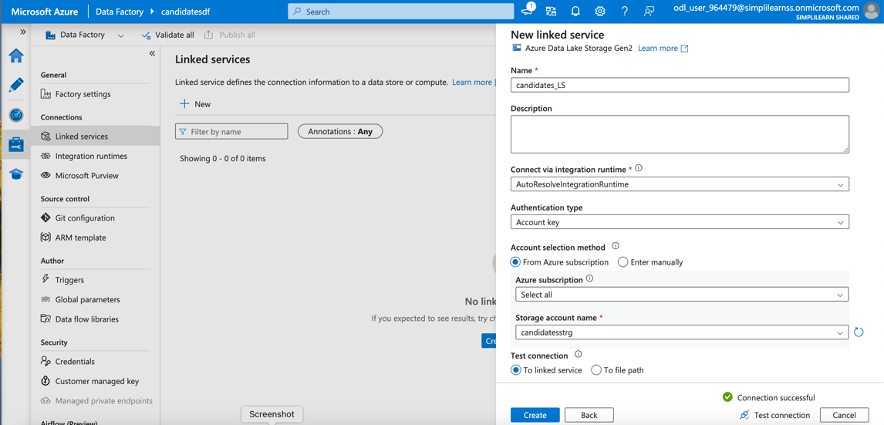



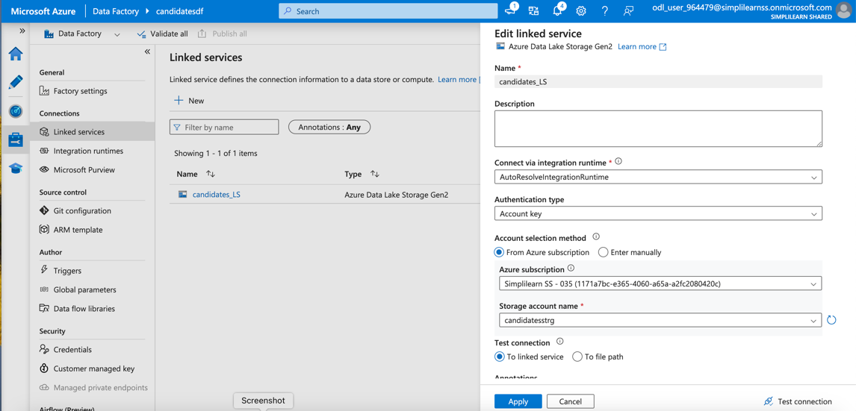



* Create first dataset for CSV files

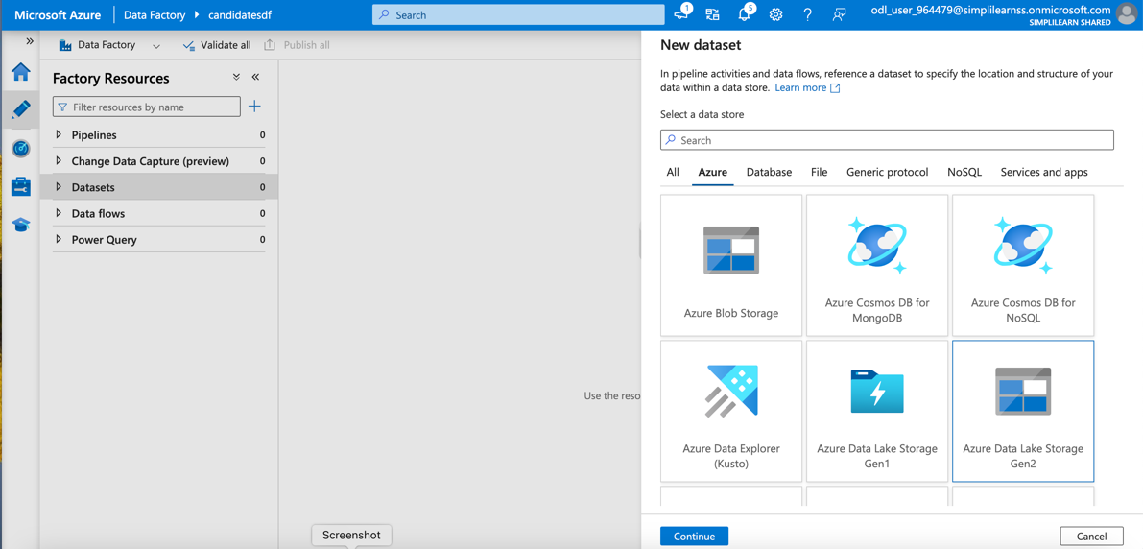



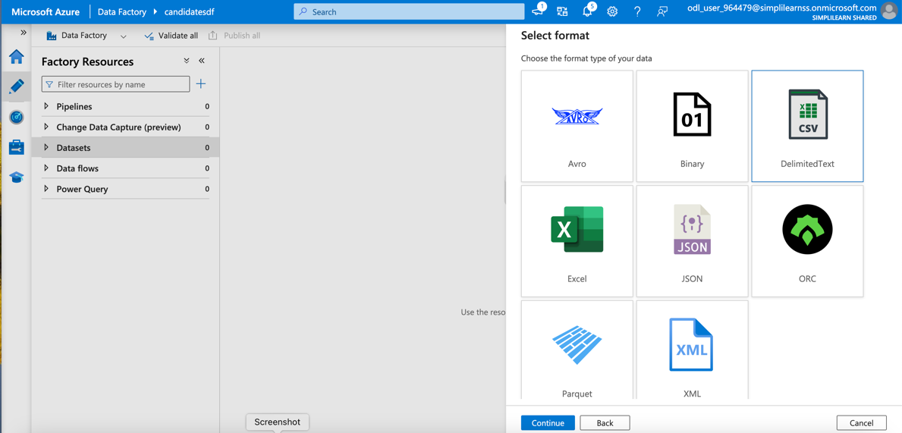



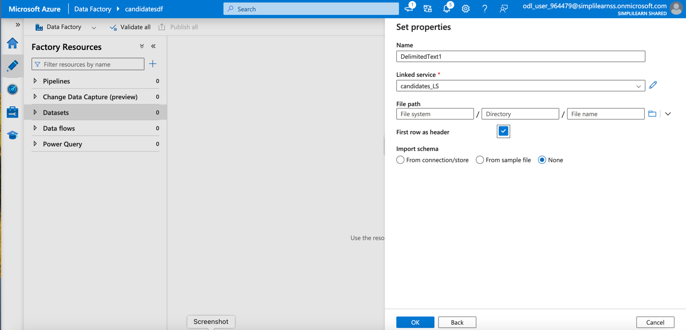



* Create second dataset for parquet file

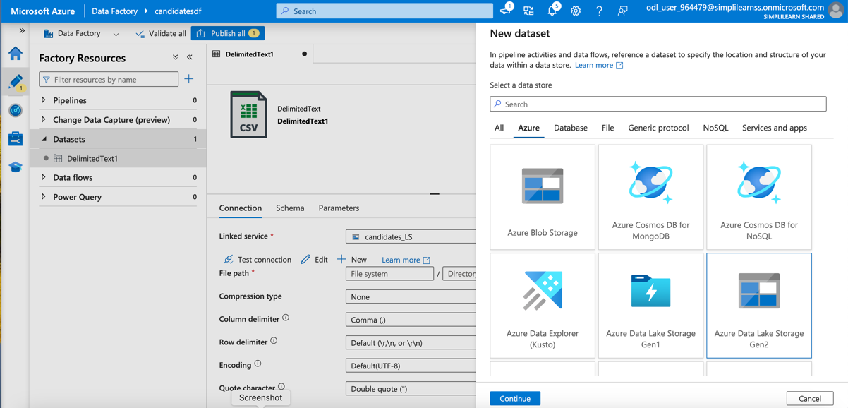



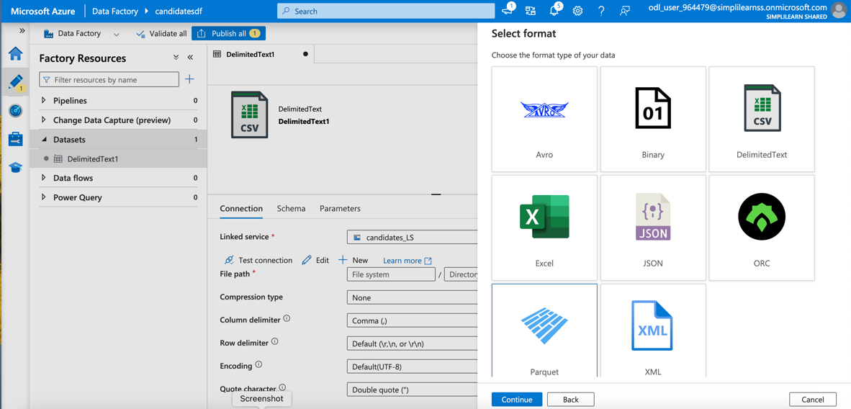



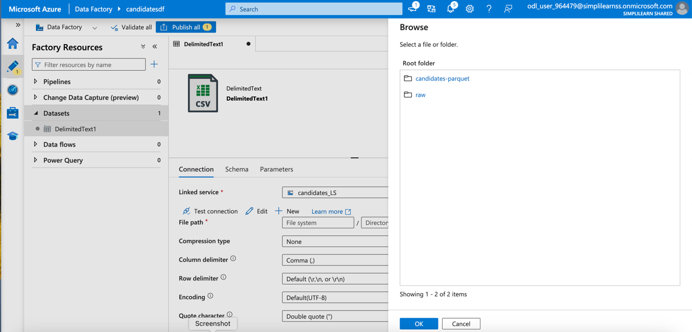

1. Use Azure Databricks as a part of the ADF pipeline
2. Create a linked service in ADF for Databricks

* Creating Pipeline

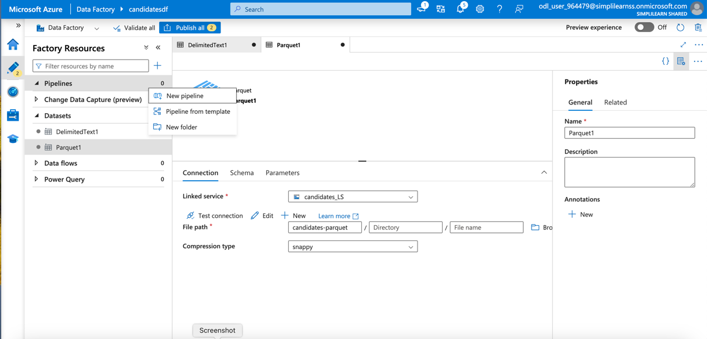



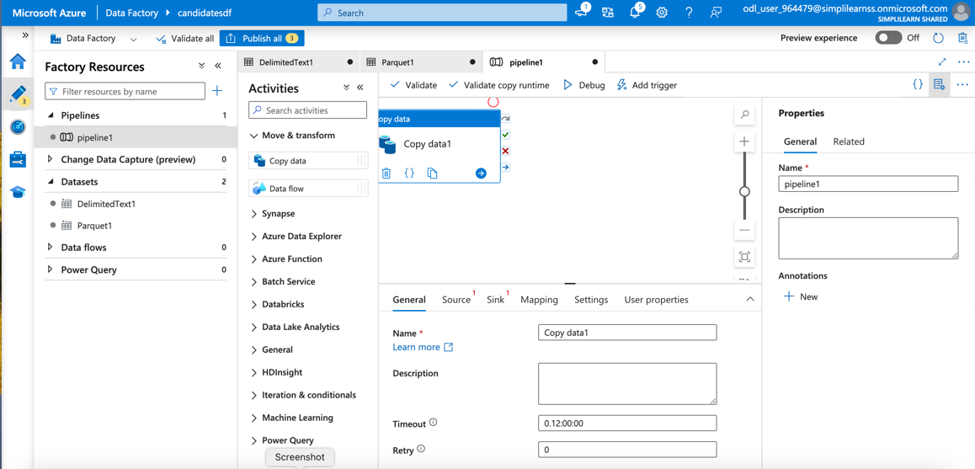



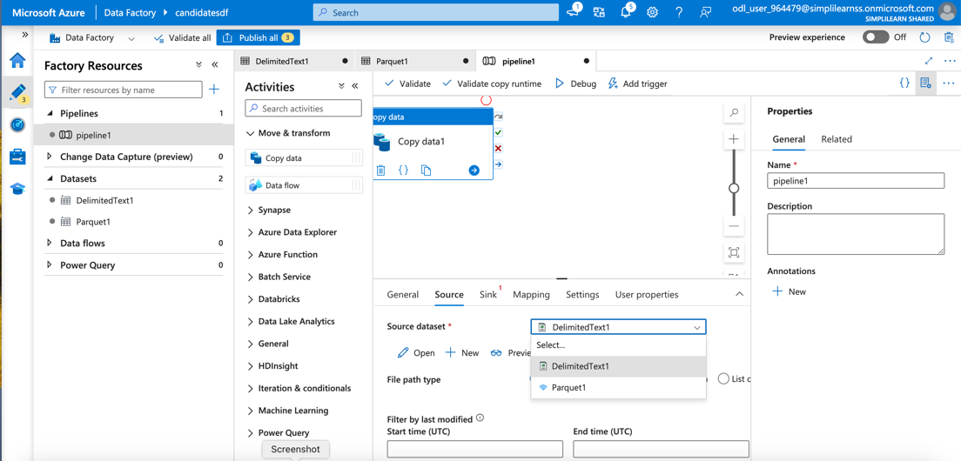



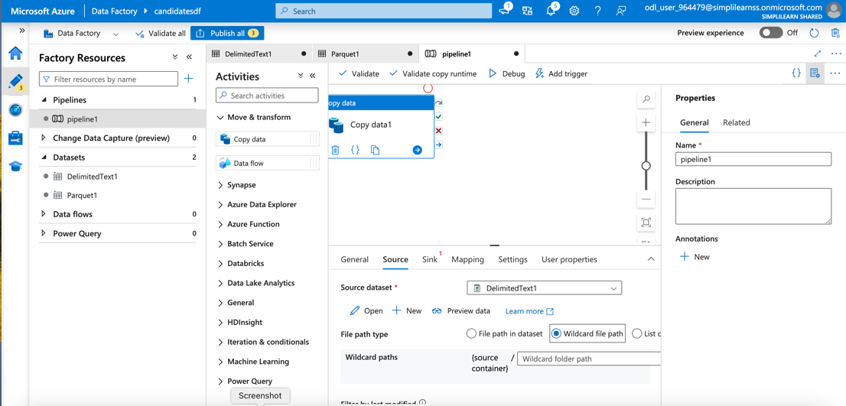



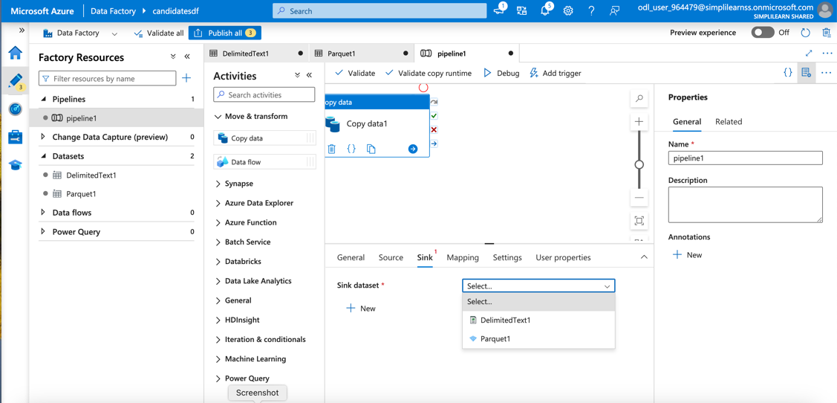



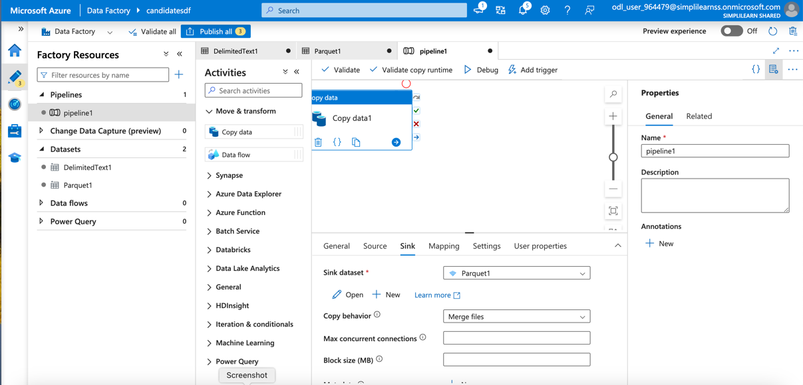



* Validate and Publish the Pipeline

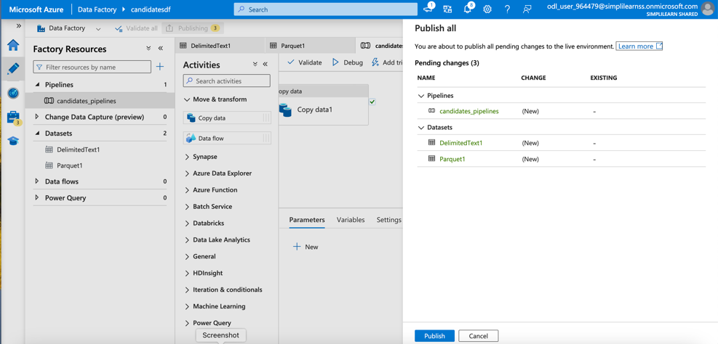



1. Convert the CSV files to Parquet files in staging storage

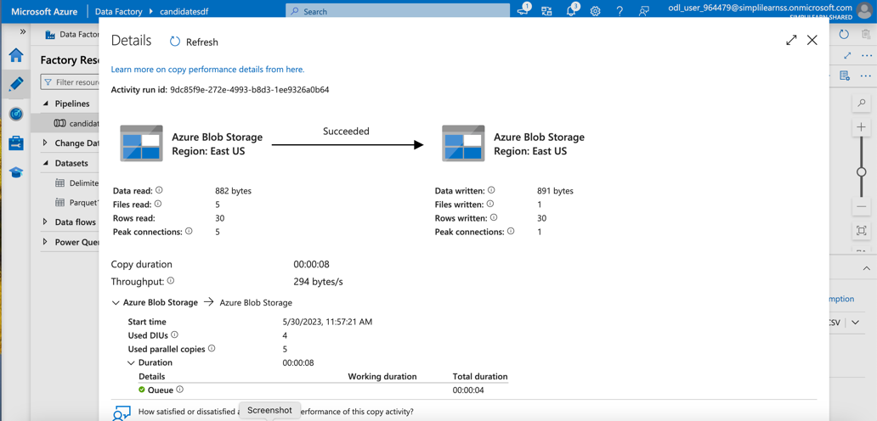



* Parquet file successfully created and saved in storage

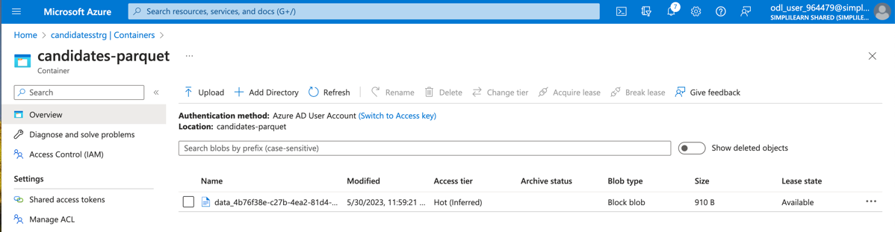



1. Access Parquet files from the staging account in Azure Databricks

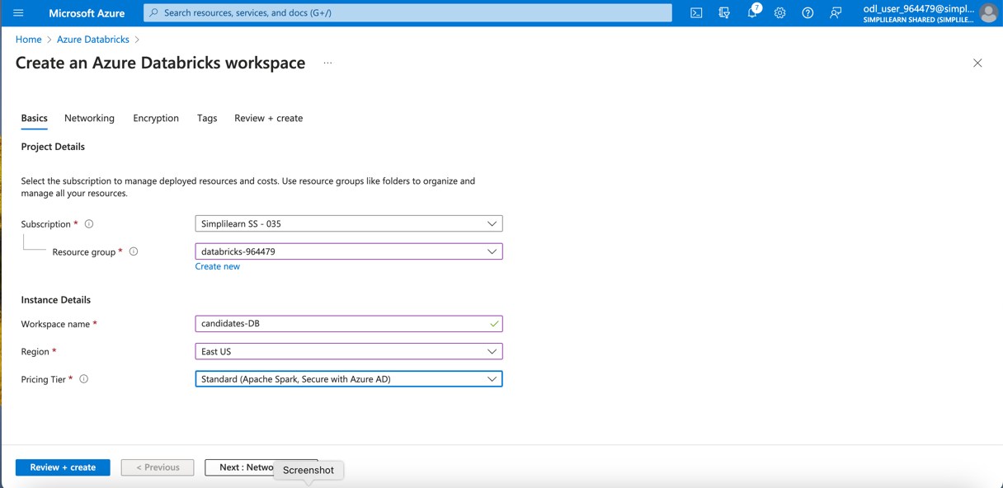



* Go to Azure DataBricks Workspace
  + Create new cluster

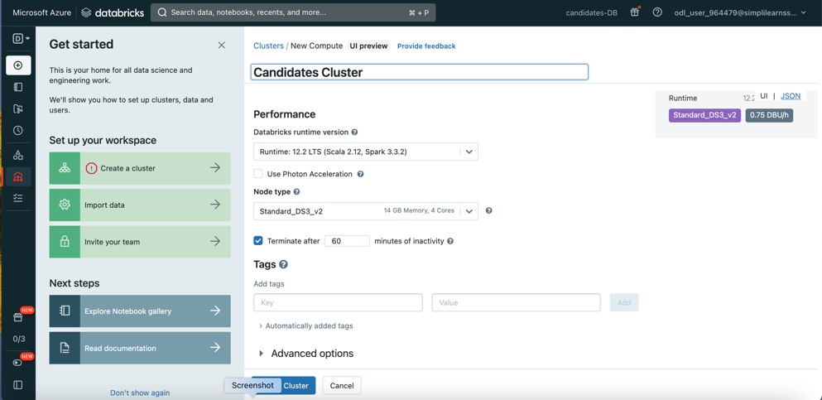

* Create new notebook inside workspace
* Mount the Parquet files from Azure storage

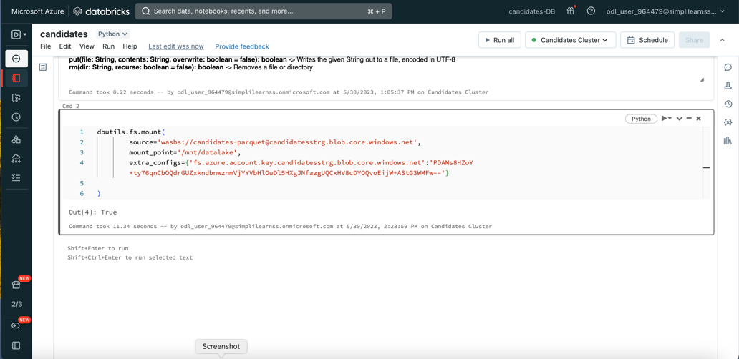



`

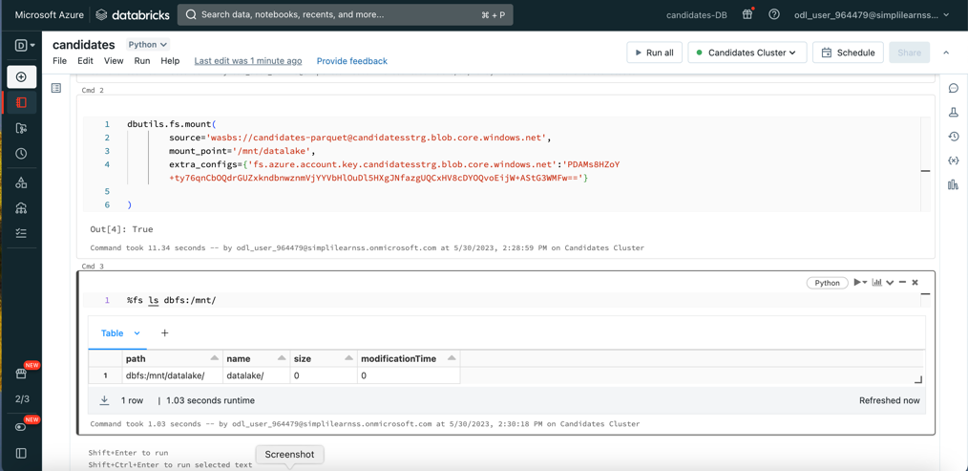



1. Convert the Parquet files to Azure Databricks Delta tables
   1. Create a data frame and load the parquet file in it
   2. Display the loaded file

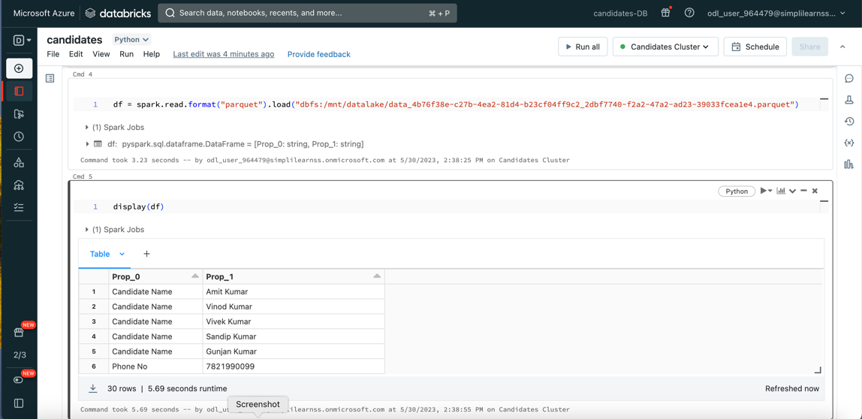

1. Store and visualize the data from Azure Databricks Delta tables

